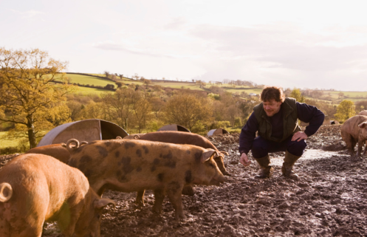  I’m a swine nutritionist. I balance pigs’ rations so they get all the nutrients they need. These pigs need these feed components to stay healthy:  Pig’s Feed Component Representative  Water Blue M&Ms  Carbohydrates (Corn) Toasted Oats/Corn nuts  Protein (Soybeans) Soy Nuts  Vitamins Nerds Candy  Minerals Raisins  Fat (Oil or Tallow) White Chocolate Chips | I’m a swine nutritionist. I balance pigs’ rations so they get all the nutrients they need. These pigs need these feed components to stay healthy:  Pig’s Feed Component Representative  Water Blue M&Ms  Carbohydrates (Corn) Toasted Oats/Corn Nuts  Protein (Soybeans) Soy Nuts  Vitamins Nerds Candy  Minerals Raisins  Fat (Oil or Tallow) White Chocolate Chips
I’m a swine nutritionist. I balance pigs’ rations so they get all the nutrients they need. These pigs need these feed components to stay healthy:  Pig’s Feed Component Representative  Water Blue M&Ms  Carbohydrates (Corn) Toasted Oats/Corn Nuts  Protein (Soybeans) Soy Nuts  Vitamins Nerds Candy  Minerals Raisins  Fat (Oil or Tallow) White Chocolate Chips | I’m a swine nutritionist. I balance pigs’ rations so they get  all the nutrients they need.  These pigs need these feed  components to stay healthy:  Pig’s Feed Component Representative  Water Blue M&Ms  Carbohydrates (Corn) Toasted Oats/Corn Nuts  Protein (Soybeans) Soy Nuts  Vitamins Nerds Candy  Minerals Raisins  Fat (Oil or Tallow) White Chocolate Chips

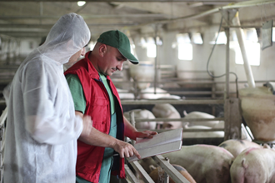  I’m a swine veterinarian. I take care of the pigs’ health. These pigs need these feed components to stay healthy:  Pig’s Feed Component Representative  Water Blue M&Ms  Carbohydrates (Corn) Toasted Oats/Corn Nuts  Protein (Soybeans) Soy Nuts  Vitamins Nerds Candy  Minerals Raisins  Fat (Oil or Tallow) White Chocolate Chips | 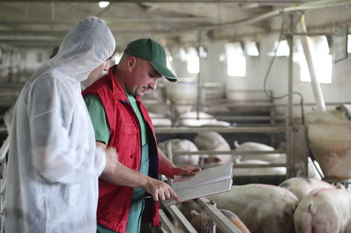  I’m a swine veterinarian. I take care of the pigs’ health. These pigs need these feed components to stay healthy:  Pig’s Feed Component Representative  Water Blue M&Ms  Carbohydrates (Corn) Toasted Oats/Corn Nuts  Protein (Soybeans) Soy Nuts  Vitamins Nerds Candy  Minerals Raisins  Fat (Oil or Tallow) White Chocolate Chips
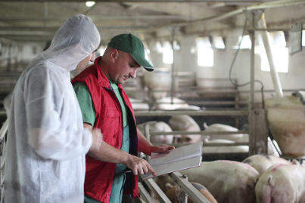  I’m a swine veterinarian. I take care of the pigs’ health. These pigs need these feed components to stay healthy:  Pig’s Feed Component Representative  Water Blue M&Ms  Carbohydrates (Corn) Toasted Oats/Corn Nuts  Protein (Soybeans) Soy Nuts  Vitamins Nerds Candy  Minerals Raisins  Fat (Oil or Tallow) White Chocolate Chips | 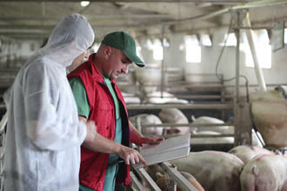  I’m a swine veterinarian. I take care of the pigs’ health. These pigs need these feed components to stay healthy:  Pig’s Feed Component Representative  Water Blue M&Ms  Carbohydrates (Corn) Toasted Oats/Corn Nuts  Protein (Soybeans) Soy Nuts  Vitamins Nerds Candy  Minerals Raisins  Fat (Oil or Tallow) White Chocolate Chips

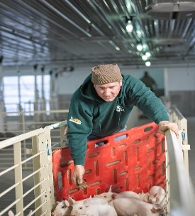  I’m a hog farmer. I take care of the pigs every day. I make sure my pigs eat these feed components to stay healthy:  Pig’s Feed Component Representative  Water Blue M&Ms  Carbohydrates (Corn) Toasted Oats/Corn Nuts  Protein (Soybeans) Soy Nuts  Vitamins Nerds Candy  Minerals Raisins  Fat (Oil or Tallow) White Chocolate Chips | I’m a hog farmer. I take care of the pigs every day. I make sure my pigs eat these feed components to stay healthy:  Pig’s Feed Component Representative  Water Blue M&Ms  Carbohydrates (Corn) Toasted Oats/Corn Nuts  Protein (Soybeans) Soy Nuts  Vitamins Nerds Candy  Minerals Raisins  Fat (Oil or Tallow) White Chocolate Chips
I’m a hog farmer. I take care of the pigs every day. I make sure my pigs eat these feed components to stay healthy:  Pig’s Feed Component Representative  Water Blue M&Ms  Carbohydrates (Corn) Toasted Oats/Corn Nuts  Protein (Soybeans) Soy Nuts  Vitamins Nerds Candy  Minerals Raisins  Fat (Oil or Tallow) White Chocolate Chips | I’m a hog farmer. I take care of the pigs every day. I make sure my pigs eat these feed components to stay healthy:  Pig’s Feed Component Representative  Water Blue M&Ms  Carbohydrates (Corn) Toasted Oats/Corn Nuts  Protein (Soybeans) Soy Nuts  Vitamins Nerds Candy  Minerals Raisins  Fat (Oil or Tallow) White Chocolate Chips

